Lab 3 Deliverables

Circuit Schematic

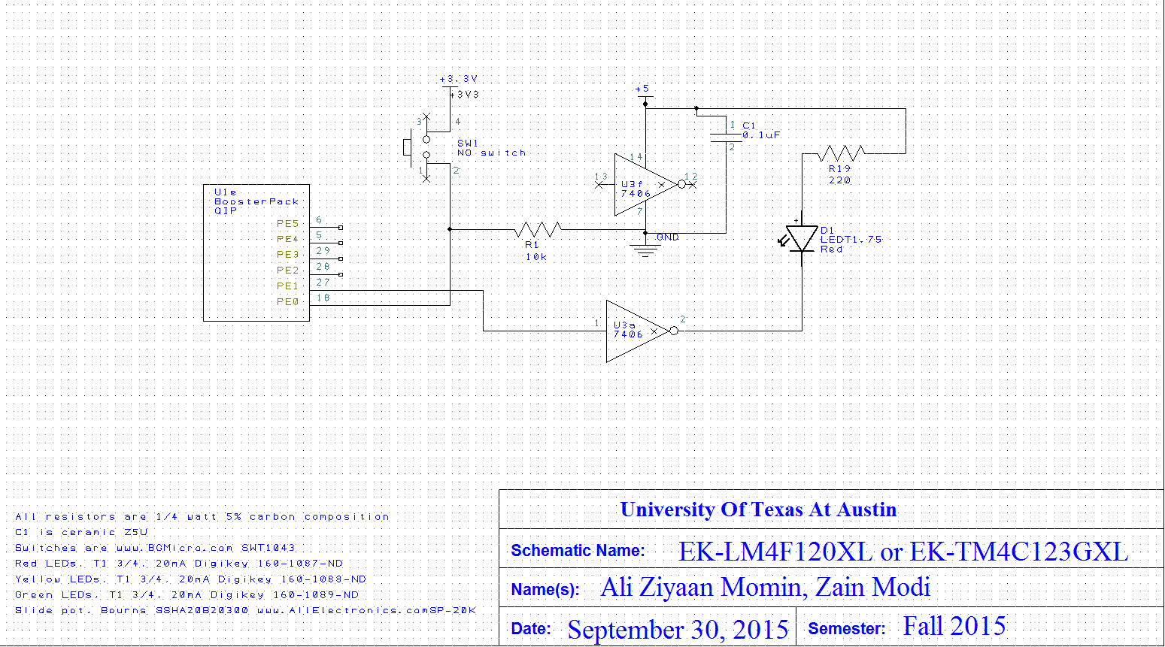

Debugger Screenshot



| Parameter | | Value | Units | Conditions |
| --- | --- | --- | --- | --- |
| Resistance of the 10 KΩ resistor, R1 | | 9800 Ω | Ohms | With power off and disconnected from circuit (ohmmeter |
| Supply Voltage V(+3.3) | | 3.292 V | Volts | Powered (Voltmeter) |
| Input Voltage V(PE0) | | 0.0045 V | Volts | Powered, vut with switch not pressed (Voltmeter) |
| Resistor Current | | 0.00 mA | mA | Powered, but switch not pressed I=V(PE0)/R1 |
| Input Voltage V(PE0) | | 3.277 V | Volts | Powered and with switch pressed (Voltmeter) |
| Resistor Current | | 0.335 mA | mA | Powered and switch pressed |
|  | |  |  |  |
| Row | Parameter | Value | Units | Conditions |
| 1 | Resistance of the 220 Ω, R10 | 219.7 | Ohms | With power off and disconnected from circuit (Measured with ohmmeter) |
| 2 | +5 V power supply V(+5) | 5.02 | Volts | (Measured with Voltmeter, notice that the +5V power is not exactly +5 volts) |
| 3 | TM4C123 Output, VPE1 input to 7406 | 0.0004 | Volts | with PE1 = 0 (measured with voltmeter) |
| 4 | 7406 Output, Vk- LED k- | 3.286 | Volts | with PE1 = 0 (measured with voltmeter) |
| 5 | LED a+, Va+  Bottom side of R10 | 1.996 | Volts | With PE1= 0 (measured with voltmeter) |
| 6 | LED Voltage | 1.930 | Volts | calculated as Va+ - Vk- |
| 7 | LED Current | 0.306 | mA | calculated as (V+5 - Va+)/R10 and measured with an ammeter |
| 8 | TM4C123 Output, VPE1 input to 7406 | 3.284 | Volts | with PE1 = 1 (Measured with voltmeter) |
| 9 | 7406 Output, Vk- LED k- | 2.278 | Volts | with PE1 = 1 (Measured with voltmeter) |
| 10 | LED a+, Va+ Bottom side of R10 | 3.283 | Volts | with PE1 = 1 (Measured with voltmeter) |
| 11 | LED Voltage | 1.063 | Volts | calculated as Va+ - Vk- |
| 12 | LED Current | 13.33 / 0.00  Theoretically( 7.89) | mA | calculated as (V+5 - Va+)/R10 and measured with ammeter |

;****************** main.s ***************

; Program written by: Ali Ziyaan Momin, Zain Modi

; Date Created: 9/29/2015

; Last Modified: 9/30/2015

; Section 4-5pm WED TA: Jenny Chen

; Lab number: 3

; Brief description of the program

; If the switch is presses, the LED toggles at 8 Hz

; Hardware connections

; PE0 is switch input (1 means pressed, 0 means not pressed)

; PE1 is LED output (1 activates external LED on protoboard)

;Overall functionality of this system is the similar to Lab 2, with five changes:

;1- the pin to which we connect the switch is moved to PE0,

;2- you will have to remove the PUR initialization because pull up is no longer needed.

;3- the pin to which we connect the LED is moved to PE1,

;4- the switch is changed from negative to positive logic, and

;5- you should increase the delay so it flashes about 8 Hz.

; Operation

; 1) Make PE1 an output and make PE0 an input.

; 2) The system starts with the LED on (make PE1 =1).

; 3) Wait about 62 ms

; 4) If the switch is pressed (PE0 is 1), then toggle the LED once, else turn the LED on.

; 5) Steps 3 and 4 are repeated over and over

GPIO_PORTE_DATA_R EQU 0x400243FC

GPIO_PORTE_DIR_R EQU 0x40024400

GPIO_PORTE_AFSEL_R EQU 0x40024420

GPIO_PORTE_DEN_R EQU 0x4002451C

GPIO_PORTE_AMSEL_R EQU 0x40024528

GPIO_PORTE_PCTL_R EQU 0x4002452C

SYSCTL_RCGCGPIO_R EQU 0x400FE608

TIME_DELAY EQU 0x000F3D40

IMPORT TExaS_Init

AREA |.text|, CODE, READONLY, ALIGN=2

THUMB

EXPORT Start

Start

; TExaS_Init sets bus clock at 80 MHz

BL TExaS_Init ; voltmeter, scope on PD3

; you initialize PE1 PE0

BL PortE_Init ;subroutine that initializes port E

LDR R1, =GPIO_PORTE_DATA_R ;turn on led via PE1

LDR R0, [R1]

ORR R0, R0, #0x02

STR R0, [R1]

CPSIE I ; TExaS voltmeter, scope runs on interrupts

loop

BL Delay ;go to delay subroutine

LDR R1, =GPIO_PORTE_DATA_R ;the following steps compare PE0 to zero

LDR R0, [R1]

AND R2, R0, #0x01 ;mask data register to obtain value of PE0

CMP R2, #0x01 ;compare PE0 to zero

BNE TON ;if not equal to zero then go to TON (turn on

;subroutine), this means switch is not ;pressed

LDR R1, =GPIO_PORTE_DATA_R ;the following steps will turn off the LED via PE1

LDR R0, [R1]

EOR R0, R0, #0x02 ;the exclusive or will make the LED turn off since 1EOR1 = 0

STR R0, [R1] ;store the PE1 modification back to the data register

B DONE

TON ;the section toggles led via PE1 bit being flipped

LDR R1, =GPIO_PORTE_DATA_R

LDR R0, [R1]

ORR R0, #0x02

STR R0, [R1]

DONE

B loop

PortE_Init

LDR R1, =SYSCTL_RCGCGPIO_R ;activate clock

LDR R0, [R1]

ORR R0, R0, #0x0010

STR R0, [R1]

NOP

NOP

NOP

NOP ;delay to allow time for clock to activate

LDR R1, =GPIO_PORTE_DIR_R ;the subroutine that turns on the led via PE0

LDR R0, [R1]

ORR R0, R0, #0x02

BIC R0, #0x01

STR R0, [R1]

LDR R1, =GPIO_PORTE_AFSEL_R ;turn off alternate function for bits PE0 and PE1

LDR R0, [R1]

BIC R0, R0, #0x03

STR R0, [R1]

LDR R1, =GPIO_PORTE_DEN_R ;digital enable on PE0 and PE1 bits

LDR R0, [R1]

ORR R0, R0, #0x03

STR R0, [R1]

BX LR

Delay

LDR R0, =TIME_DELAY ;move the number 200000 into R0

Decrement

ADD R0, R0, #-1 ;decrement by 1

CMP R0, #0x00 ;compare to 0

BNE Decrement ;if not equal to zero keep decrementing

BX LR

ALIGN ; make sure the end of this section is aligned

END ; end of file